NAME: __________________________ DATE DUE: ____________
TEACHER: ________________________
/28
Year 9 Term 4 – Body Systems
HOMEWORK SHEET No. 3 – Learning Goal 3

 | - Write a definition for each of the following terms:
/1 | (a) Circulation system –
/1 | (b) Oxygenated (blood) –
/1 | (c) Deoxygenated (blood) -
/1 | (d) Haemoglobin -
/1 | (e) Pulmonary -
/6 | 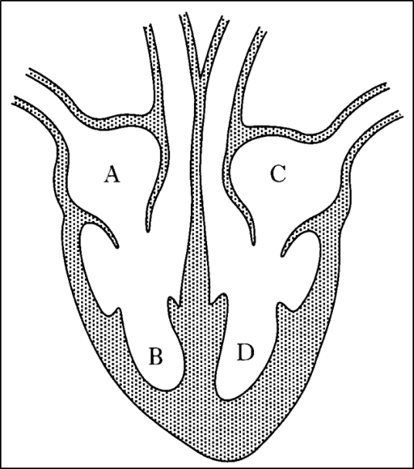  - (a) On the diagram below label  (i) right atrium, right ventricle, left atrium, left ventricle  (ii) Aorta, pulmonary artery, pulmonary vein, vena cava  (b) On the diagram, draw arrows showing the correct direction of blood flow through the heart.
 | - In a single sentence for each question, describe the role of each of the following components of blood.
/1 | (a) red blood cells -
/1 | (b) plasma -
/1 | (c) white blood cells -
/1 | (d) platelets -
/3 | - Each of the statements below describes a type of blood vessel. In the space provided write the name of the blood vessel described by the statement – names may be used more than once.  _______________ 1. the smallest type of blood vessel  _______________ 2. Type of blood vessel that carries blood toward the heart  _______________ 3. carries oxygen  _______________ 4. muscular blood vessel that carries blood away from the heart  _______________ 5. The exchange of gases between body cells and blood takes place across the walls of these vessels  _______________ 6. generally carry deoxygenated blood
/5  /2  /3 | - The table shows results of an investigation using an exercise bike carried out by Kelly. She started by resting for 10 minutes and then cycled for 15 minutes at a constant pace and then resting for another 10 minutes. She measured her breathing and heart rate before, during, and after exercise.  (a) Draw a line graph of Kelly’s results (two lines, one for breathing rate and one for heart rate, on the one graph)  Time (min) Kelly's results  Breathing rate (breathes/min) Heart rate (beats/min)  0 14 74  5 19 122  10 24 139  15 27 145  20 13 90  25 14 75  *(b) Why does breathing rate increase when you exercise?  **(c) Use data from the graph to justify your answer to (b)
 | Directive verbs | Meaning
 | Define | Gives the meaning of the word, phrase, or concept.  Typically begins with: A “____________“is...
 | Describe | Give an account of a situation, event, pattern, or process or give an account of the characteristics or features of something.  Describing is the “what, not the “why”. This means that describing should only tell you what something is, what it looks like, or what it does. Describing does not explain or justify - these two words are the “why” descriptive verbs

